B. In-Depth Explanation & Analysis
- VSEPR Theory & Hybridization This is the most common area for mistakes.
- Geometry vs. Shape:
  - Geometry (Electron Geometry): Includes all electron pairs (bonds + lone pairs).
  - Shape (Molecular Geometry): Look only at the atoms (ignore lone pairs visually, but acknowledge their repulsion).
  - Example: Ammonia $\left({NH}_{3}\right)$. Geometry $=$ Tetrahedral $(4$ electron pairs $)$. Shape $=$ Trigonal Pyramidal (one position is a "ghost" lone pair).
- Hybridization Trick: Count Sigma bonds + Lone Pairs.
- Sum $=2$ (sp, linear)
- Sum $=3\left(sp^{2}\right.$, trigonal planar $)$
- Sum $=4\left(sp^{3}\right.$, tetrahedral)
- Sum $=5\left(sp^{3}d\right.$, trigonal bipyramidal)
- Sum $=6\left(sp^{3}d^{2}\right.$, octahedral)
Mentor insight: Learning where to draw and place lone pairs in a bond diagram is crucial to figure out the shape of the molecule.
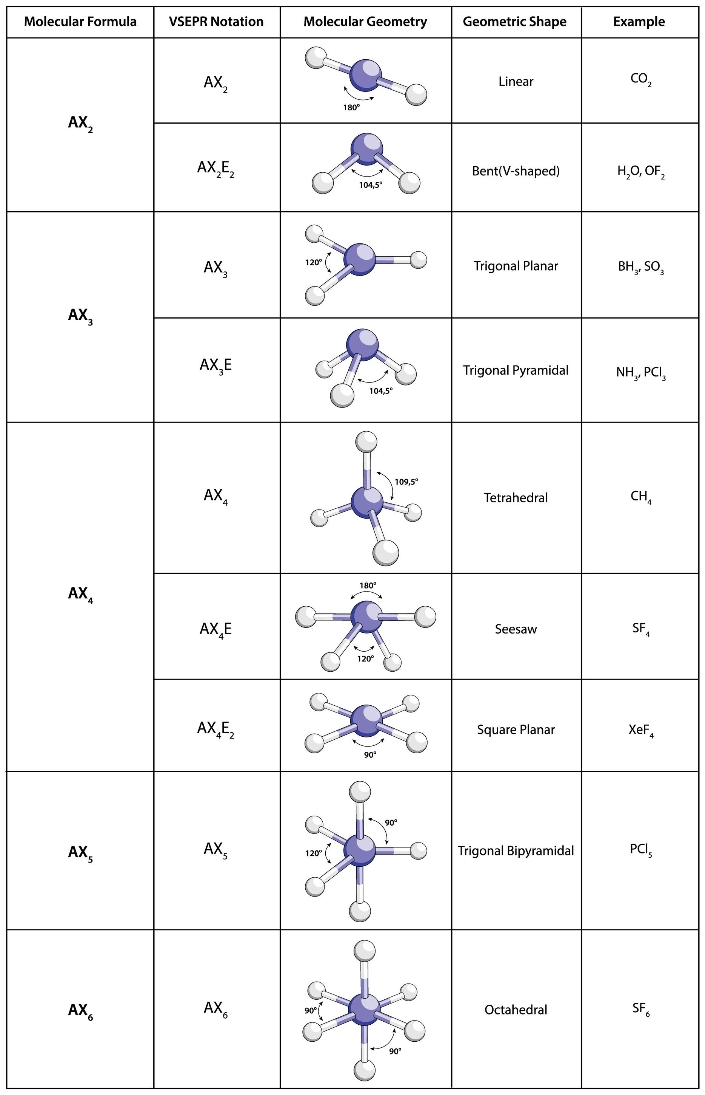
2. Sigma ( $σ$ ) vs. Pi ( $π$ ) Bonds
- Sigma: Head-on overlap. Stronger. Free rotation allowed.
- Pi: Sideways overlap. Weaker. No rotation (locks geometry).
- Note: A single bond is always $σ$. A double bond is $1σ+1π$. A triple bond is $1σ+2π$.
3. Molecular Orbital Theory (MOT)
- This theory constructs new orbitals $\left(σ,σ^{*},π,π^{*}\right)$ by Linear Combination of Atomic Orbitals (LCAO).
- Bond Order: $\frac{1}{2}\left(N_{b}-N_{a}\right)$.
- If Bond Order $>0$, molecule exists.
- Higher Bond Order = Stronger bond = Shorter bond length.
- Magnetic Nature: If unpaired electrons are present in MO diagram → Paramagnetic. If all paired ⟶ Diamagnetic.
Mentor insight: MOT commonly appears as a 5 marker.

